**Data Analysis & Visualisation Using Tableau**

**Module: Tools for Data Analytics**

**Student: Galina Lopez 10333429**

1. Workbook and Graphs

Tableau 9.2 version used for this assignment. Workbook: Book2 with all graphs, dashboard and story was exported and zipped for submission. Most relevant graphs were also exported as images and used in my report of the analysis of the Salary Data, Salary Data States Corrected and Price Parity datasets.

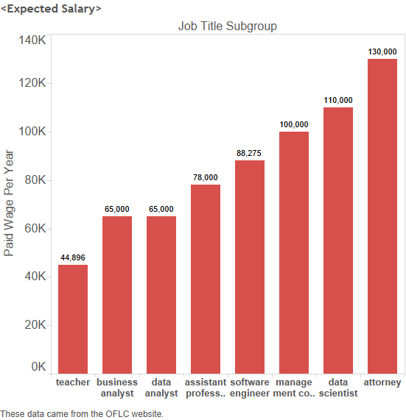

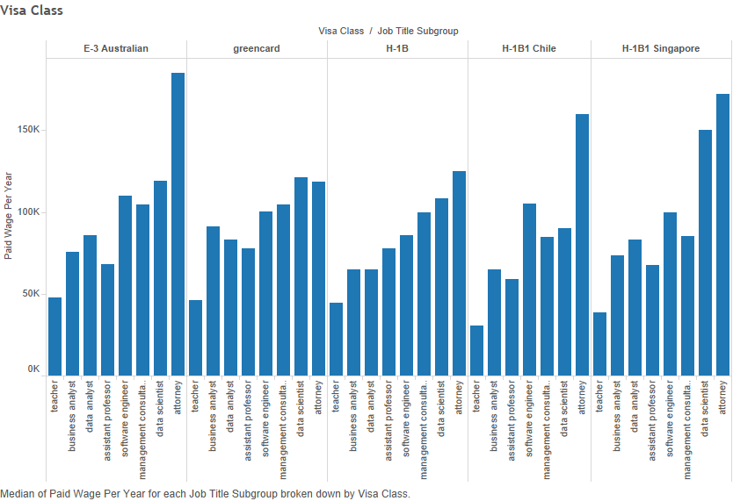

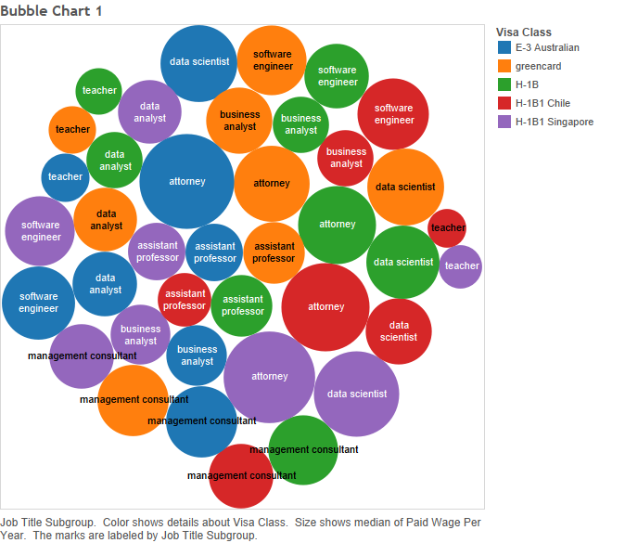

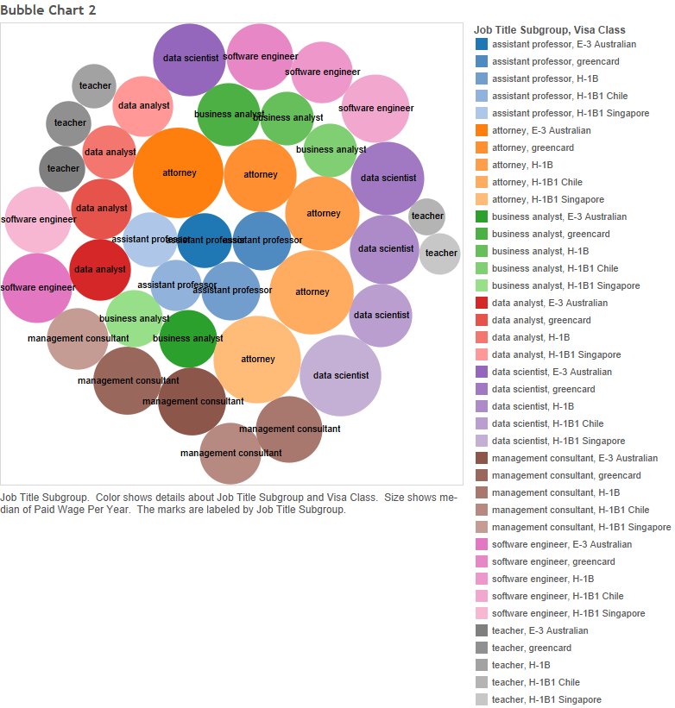

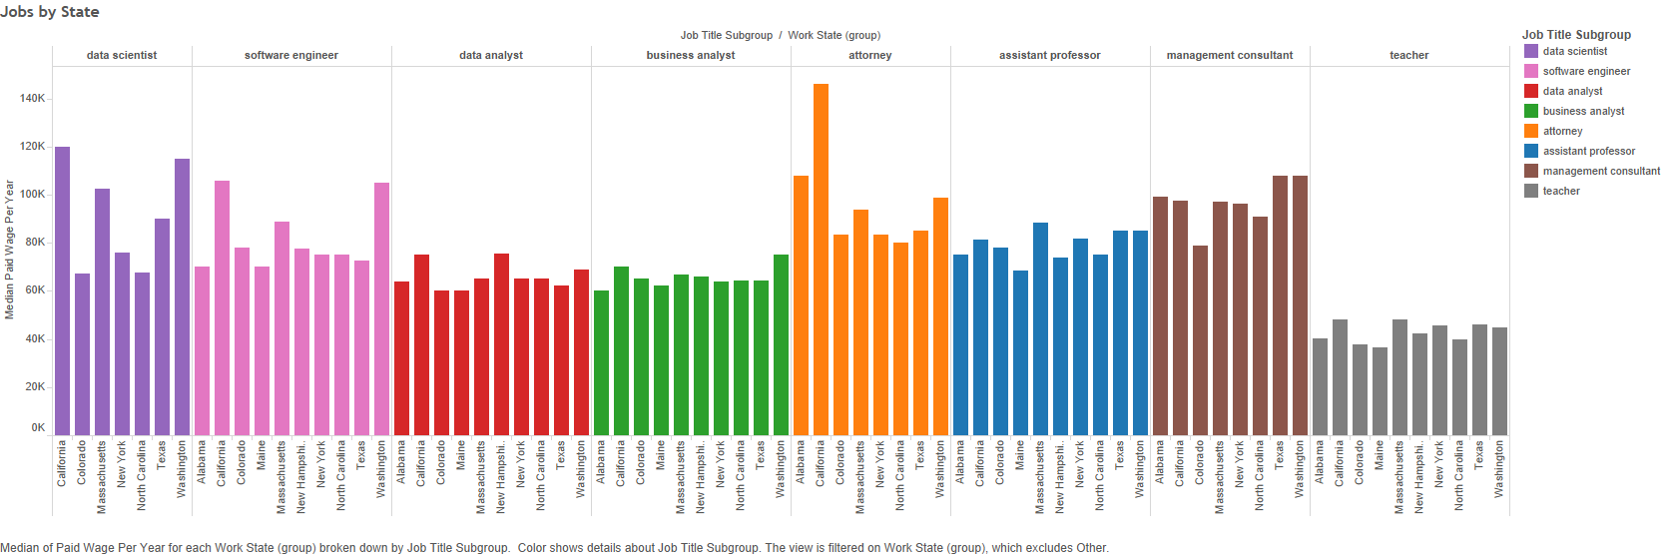

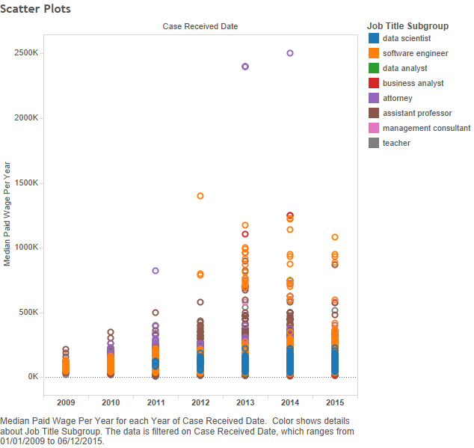

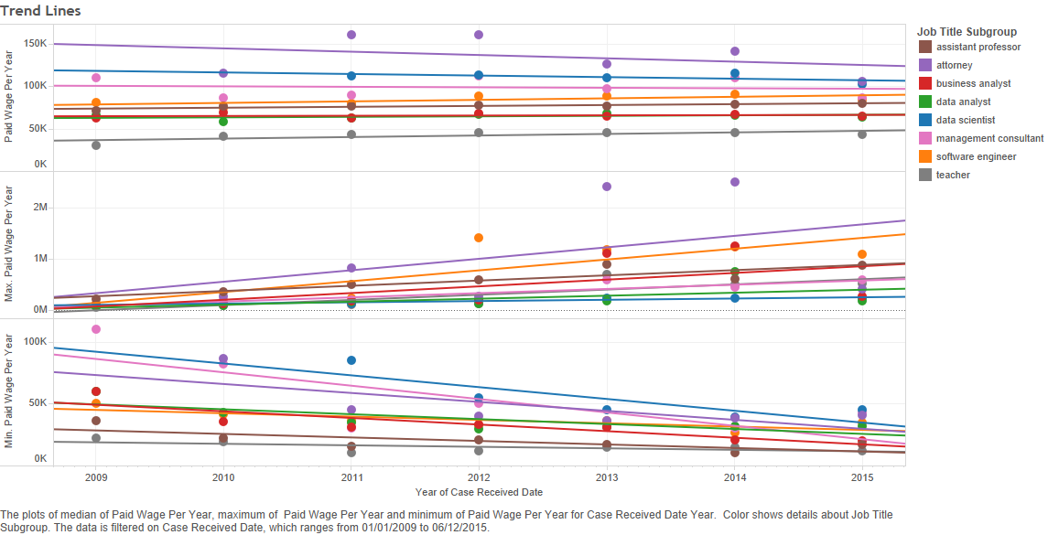

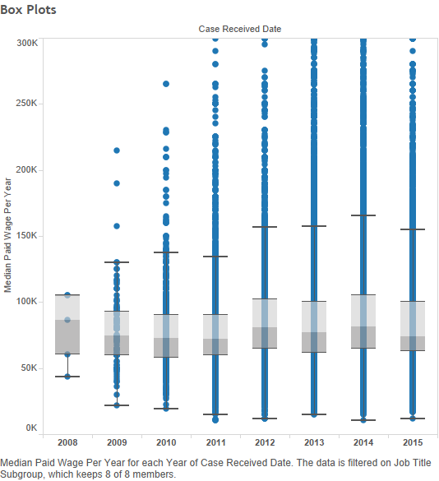

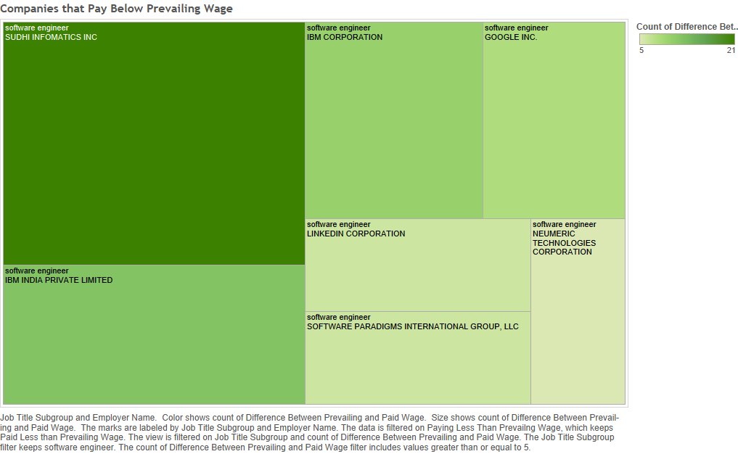

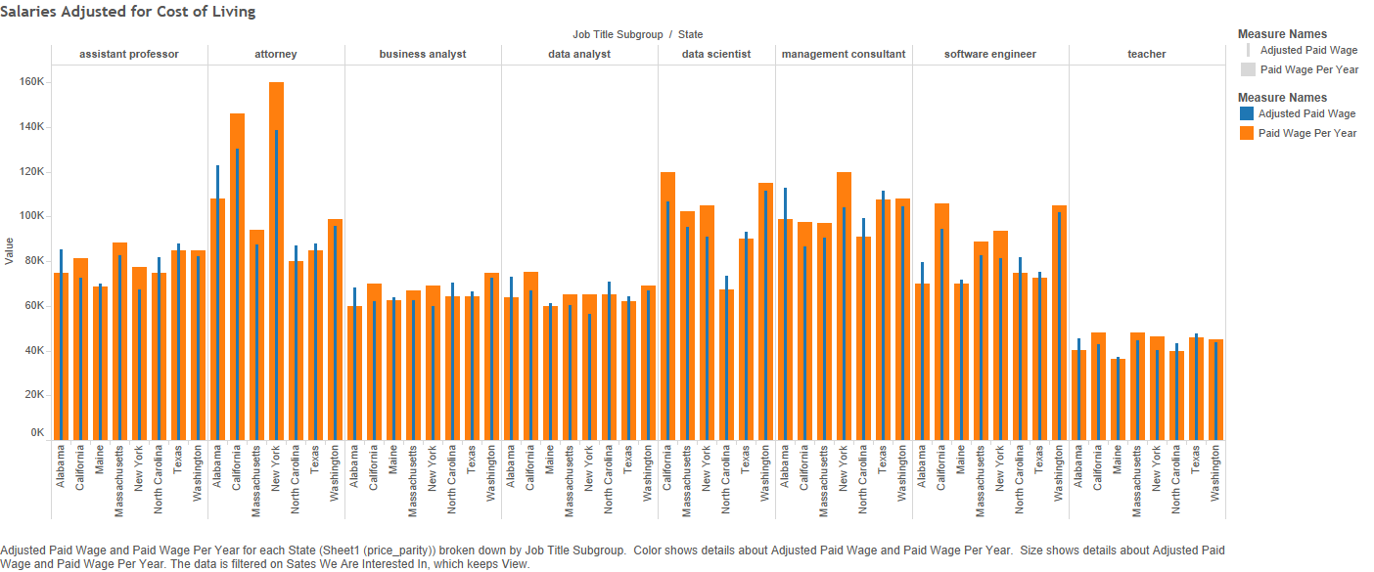

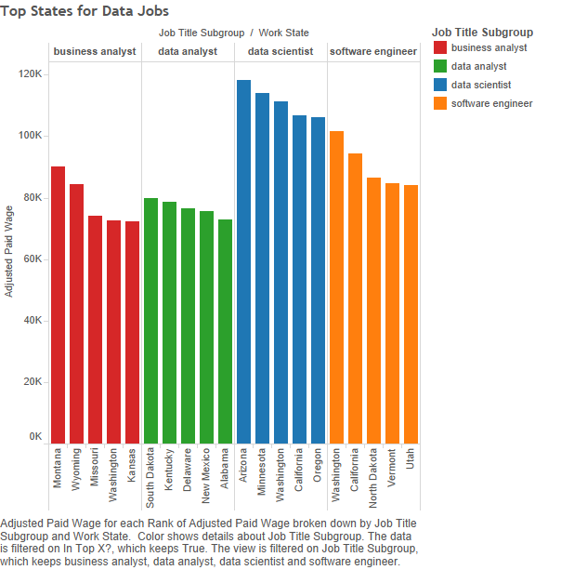



2. Salary Data Dashboard

Designed a dashboard to determine where you should apply for data related job in the United States.

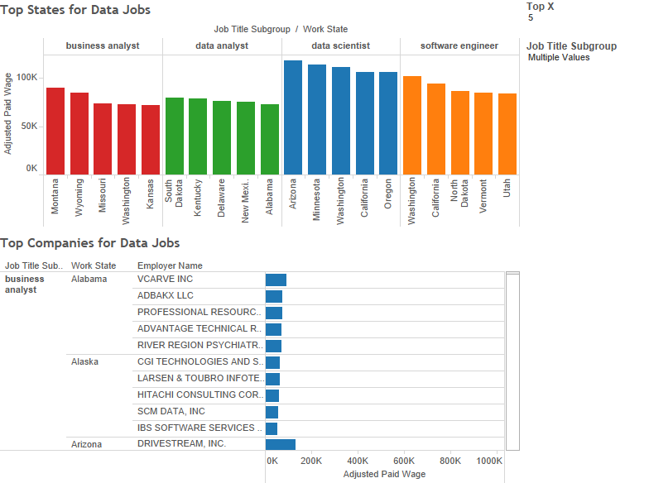

Salary Data Story using Tableau

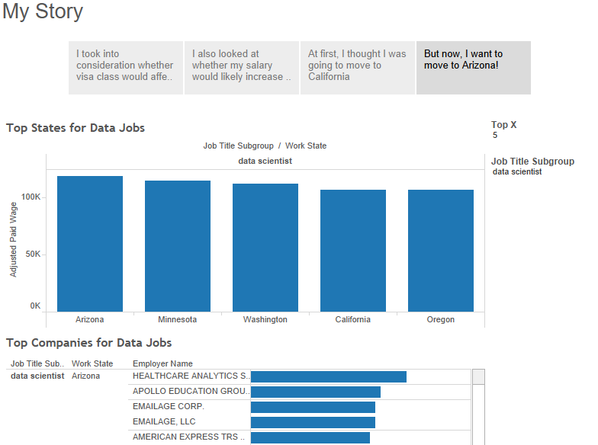

3. Report

a. An overview of what benefits Tableau 9.1 and data visualisation could bring to an organisation of your choice.

Tableau helps people see and understand their data. Gone are the days when insight from data was restricted to a few erudite analysts and IT. A new generation of business intelligence and visual analysis software puts data into the hands of the people who need it. Slow, rigid systems are no longer good enough for business users or the IT teams that support them. Competitive pressures and new sources of data are creating new requirements. Users are demanding the ability to answer their questions quickly and easily. And that’s a good thing.

Tableau was founded on the idea that data analysis and subsequent reports should not be isolated activities but should be integrated into a single visual analysis process—one that lets users quickly see patterns in their data and shift views on the fly to follow their train of thought. Tableau combines data exploration and data visualization in an easy-to-use application that anyone can learn quickly. Anyone comfortable with Excel can create rich, interactive analyses and powerful dashboards and then share them securely across the enterprise. IT teams can manage data and metadata centrally, control permissions and scale up to enterprise-wide deployments.

That’s what an organisation like Zatto has managed to achieve. Zatto has seen the benefits Tableau and data visualisation could bring to their organisation. Nowadays, Zattoo understands customer behaviour with analysis in Tableau.

With approximately 15 million registered users and more than 34 million video views per month, Zattoo is now the largest Internet TV provider in Europe. The company with head offices in Zurich is present in five European countries (Switzerland, Germany, UK, Denmark and Spain). It broadcasts a comprehensive, high-quality live TV offering that can be received on computers, smartphones, tablets and smart TVs, as well as some gaming consoles.

Zattoo is an internet TV/TV streaming provider. They have various apps for Android and iOS but also big-screen apps, for instance via the Amazon Fire Stick, which can be used to watch TV. Customers can watch live TV but also recall things, meaning that certain TV stations' programs can be streamed up to seven days after their original air date.

Before Tableau, analysts spent "ages" manually working with Hadoop, Excel table, and custom scripts. Today, they simply connect Tableau to their Vertica database to quickly analyse online behaviour. Going forward, the company aims to use Tableau to monitor their advertising campaign performance.

The main users for Tableau are the marketing, management, and product teams.

The Tableau solution uses churn rate, retention and number of MAUs or monthly active users. What are the most-watched offerings on their service? What channels are popular at certain times? What shows are popular, broken down by age group and gender? These are the initial KPIs they analyse to begin with. That’s what they are building dashboards for. Going forward, they could also carry out complete funnel analysis in the marketing team. In other words, what campaigns did the user arrive by? How many clicks did each campaign generate? And how many sign-ups? Which valuable users came from certain campaigns? So basically, which campaigns were ultimately the most effective?

In Vertica, and ultimately in the data warehouse, they tap into various data sources. These include the Hadoop archive but also some data from Google Analytics and campaign tracking. They have a partner called Adjust, which provides them with the data, and they use an API or server call back to pull the data to their data warehouse. Generally, Tableau is connected to this data warehouse—to Vertica. It contains everything about usage. In that regard, they’ve already progressed a lot so that the management team analyses daily Tableau exports or uses live dashboards to clarify management-related questions.

Everyone who sees Tableau at the company is immediately enthusiastic about it. Therefore, the satisfaction levels are relatively high, simply because the dashboards are so nice or because they can be built so nicely—and also far more intuitively compared to the old Excel ones they used to have.

Tableau offers ease of use and the speed of analysing things. Previously they used to have to pull the data out of Hadoop, import it to an Excel table, and analyse the data or generate some plots with Air scripts. It took ages, and when they made a mistake, they had to start over. This is a lot faster with Tableau—an extremely important point.

Another point is the variability and interactivity of visual illustration. They can click on things, change the KPI, set the dimensions and filters differently and thereby save a lot of time on their way to gaining insight.

Tableau allows them to play around with it. They have a hypothesis and just go wild playing around with the data to see what happens. More data means more possibility. But only if you can use that data. Real data discovery requires an interactive, visual data discovery tool that makes it easy to explore data and that’s what Tableau provides.

Ultimately, this creative process is a lot easier with Tableau. And they really appreciate that.

Not only has Gartner touted the importance of data discovery and data exploration, but thousands of Tableau customers are getting value from it every day as well.

Tableau enables people throughout an organization to investigate data to find nuances, trends, and outliers in a flash. No longer constrained to a million rows of spreadsheet data or a monthly report that only answers a few questions, people can now interact and visualize data, asking – and answering – questions at the speed of thought.

Tableau is engineered to support your existing data infrastructure and policies and provide self-service business intelligence.